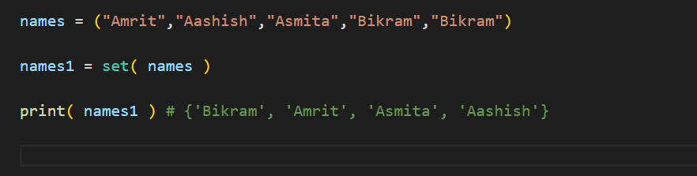

Duplication not allowed in set

We pass a tuple in set( ) constructor and constructed a set

**Accessing items in set**

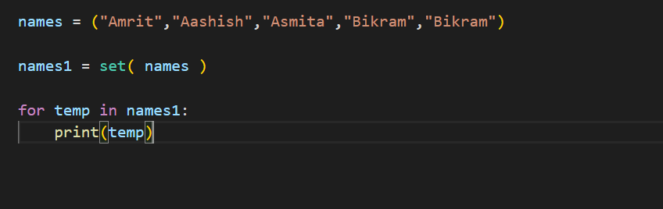

Set is stored as unordered in memory

**Adding items in set**

**.add( ) method**

To add only one item in the set

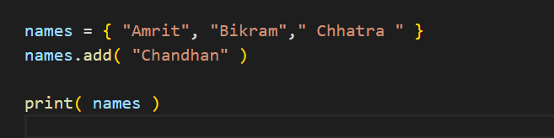

**.update( )**

Any iterable (list, tuples,set) can be passed

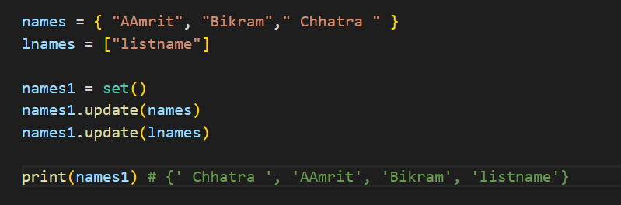

**Removing items**

**del** keyword deletes the set permanently

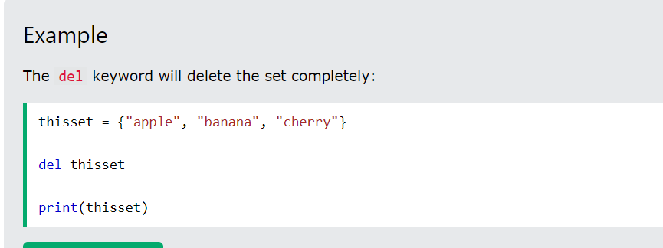

**.remove(“item_name”)**

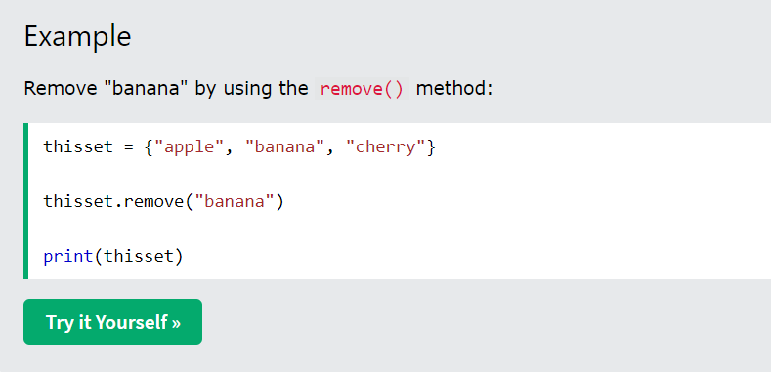

Removes the desired item

**.discard(“item_name”)**

Same as .remove( ) but it does not raise error if the item does not exist

.clear( ) method

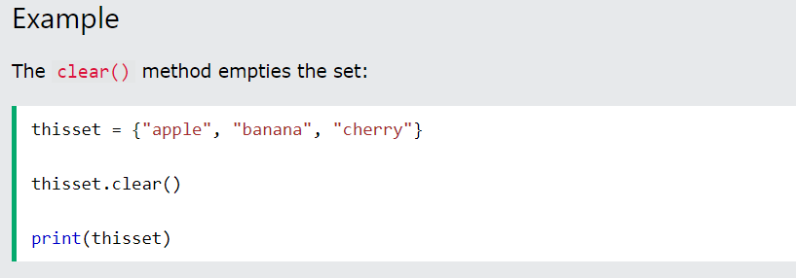

It empties the set

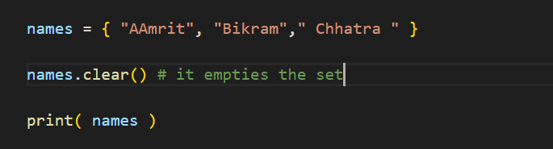

**Joining two sets**

**.union ( )**

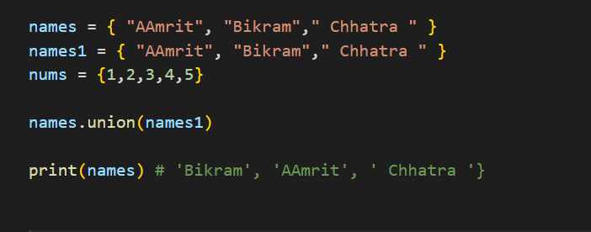

Like union operation of set

.intersection( )

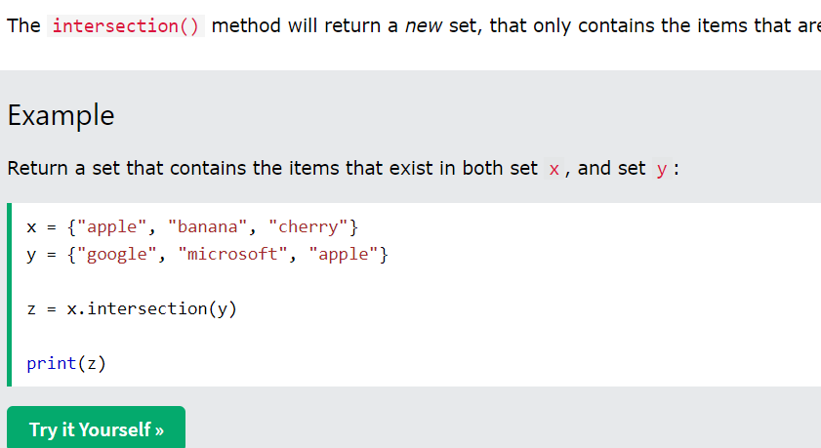

Just like the intersection operation of math

**.update( )**

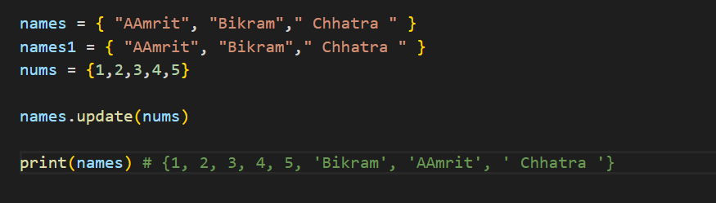

Just what name says, updates the set